
Profield Chat-v1.0
Software Requirement Specification
Revision History
Version | Author | Date | Remarks
1.0 | Suraj P | 20-10-2018 | 1.0.0.20181020

Software Requirement specification for Profield Chat Application.

Table of Contents
1 Introduction 4
1.1 Purpose 4
1.2 Scope 4
1.3 Product / System Overview 4
1.4 User Characteristics 5
2 Functional Requirements (Web /IOS) 5
2.1 User Sign up 5
2.2 User Reactivation 5
2.3 New User Invite 5
2.4 User Login 5
2.5 Send Friend request 6
2.6 Manage Friend request 6
2.7 New group 6
2.8 Text Chat 6
2.9 Emoji support in chat 6
2.10 Attachment support 6
2.11 Voice to Text support 7
2.12 Voice chat support 7
2.13 Delete Message 7
2.14 User Delete/Deregistration 7
2.15 Change Password 7
2.16 Forgot Password 7
2.17 User profile update 8
2.18 User Logout 8
2.19 Edit Group details 8
2.20 Add/Remove Member from Group 8
2.21 Assign/Revoke Group Admin Privilege 8
2.22 Delete Messages from group 8
2.23 Delete Group 8
2.24 Show online/offline status of the user 8
2.25 Group Chat Messages Based On Date 8
3 Functional Requirements (ADMIN MODULE) 9
3.1 Admin User Login 9
3.2 Admin User Logout 9
3.3 Change Password 9
3.4 Search and List Users 9
3.5 Create New user 9
3.6 Edit User Profile 9
3.7 Delete/Deactivate a user 9
3.8 Delete Message 9
4 Non-Functional Requirements 10
4.1 Performance Requirements 10
4.2 Security Requirements 10
4.3 Software System Attributes 10
5 External Interface Requirements 11
5.1 User Interfaces 11
Login Page 11
New User Sign-up Page 11
Chat Home Page 12
Manage Friend Request Page 13
New Group Creation Page 13
5.2 Hardware Interfaces 14
5.3 Software Interfaces 14
5.4 Communication Interfaces 15
6 Acceptance Criteria 15
7 Appendices 15

Introduction

Purpose

The purpose of this document is to present a detailed description of the Profield Chat Application. Description includes the purpose and features of the system, the interfaces of the system, the operations in the system and the constraints under which it must operate. This document is intended for both customers and developers of the system and shall be reviewed and approved by the customer, before proceeding with development of the system.

Scope

This system will be a Chat Application System for Profield Corporation in Japan. The Chat system will be allow. The purpose of the chat application is to allow users be able to the chat with each other, like a normal chat application. The users will be able to chat with each other privately i.e. from user to user and also publicly, i.e. into a group/forum. The chat should allow to send and receive voice messages, voice to text messages and also able to send attachments. The user configuration and the actual chat messages should be stored in a database.

Product / System Overview
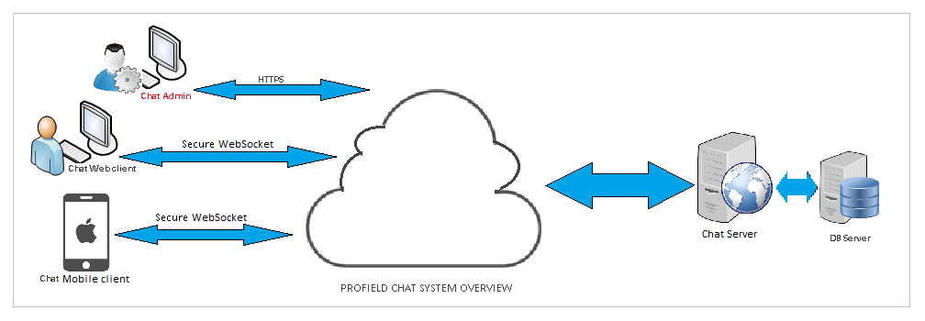
The overview of the chat system is consists of
- A responsive web client (which supports Mobile view) which will allow users to login to the chat application and chat with the online users in the contact list
- A native IOS mobile app, is very easy to use, provides instant access to friends and chat messages.
- An Admin web application, allows a admin user to manage the user in the chat.
- A Chat Web Server, provides the services to the clients and admin module

User Characteristics

There are two types of users in the chat system:
- Admin user: This user have access into the Admin module of the chat application. Admin user can manage normal users of chat.
- Normal Users: These are the general users of chat application, will be anyone who is a registered user of chat.

Functional Requirements (Web /IOS)
The functionality of the chat application is to give the ability to chat with whoever is online on the application.
There are two chat clients, a web application and an IOS app. Both clients will allow users to connect with other users and chat.

User Sign up
There is a sign up module through which anyone can register as a chat user. Username and email will be unique for a user, other details such as first name, last name and profile image will be accepted here. On registration an email will be sent to the user with a login URL.

User Reactivation
On sign up, if a deleted user record found with the same email (provided by the sign up user), user will be prompted with a confirmation message for reactivating the account. On confirmation, the delete flag will be removed and the user account will be active. All the messages belongs to the previous user session will be deleted permanently. A notification email will be sent to the user regarding the account reactivation event. If the user wants to reset the password, he/she would use the ‘Forgot Password’ option provided in the login page.

New User Invite
A chat user can invite anyone who is presently not a member of the chat, by providing his email. An email will be sent to the invitee with a register URL. On registration using this email, the inviter will be added as a friend and similarly he will be added as a friend of inviter.

User Login
A registered user can login into the chat application. After login, the chat home will be displayed with user’s contact list, and the user will be online in the contact list of his/her friends.
In IOS app, it will keep the user, unless we manually logout of the chat app. In Web application, for each time when we login a user session will be created and it will be invalidate, if the user is inactive for some time or logout from chat.

Send Friend request
This will allow a user to search for other registered users of chat, but not a friend and send a friend request. This will be notified to that user immediately if he is online.

Manage Friend request
A user can view any friend requests sent to him/her and approve or reject that request. If user approve the friend request, both the sender and receiver of friend request will become friends and the contact list of both users will be updated immediately.

New group
A group can be created and his friends can be added as the members of the group. The user who creates will become an owner of the group. The contact list of group members will be updated immediately with the new group.

Text Chat
A user would be allowed to send and receive text messages it will instantly notified to the receiver, if that user is online. If not the messages will be stored in database and when next time when the user comes online, this will be notified.

Emoji support in chat
A user would be allowed to send and receive emoji icons.

Attachment support
A user would be allowed to upload and send a file as attachment message and this will be notified to the receiver immediately. If the receiver is offline, it would be notified whenever he/she come online next time.
Attachment file types would support popular text formats, document formats, image formats, audio and video formats and some specialized formats of Adobe tools.
- PDF, TXT, DOC, DOCX, XLS, XLSX, PPT, PPTX
- JPEG, PNG
- MP2, MP3, MP4, MOV
- EPS, AI, INDD

Voice to Text support
A user would be allowed to record a voice message and it would be converted into its corresponding Japanese text, and then send as a text message.
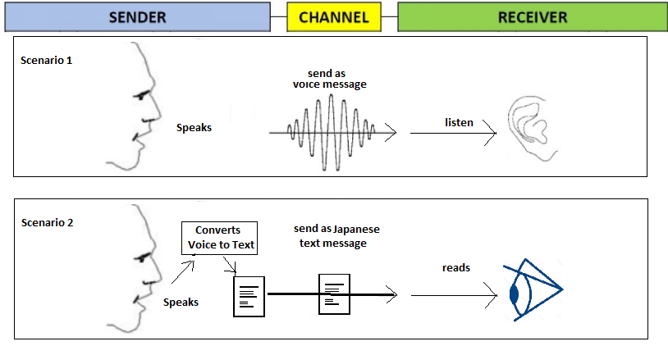

Voice chat support
A user would be allowed to record a voice message and send as a voice message to the receiver. If the receiver is not online, it would be notified whenever he/she come online next time.

Delete Message
A user would be allowed to delete a message, if he is the sender of the message. The messages are not deleted permanently from database, it is marked as deleted with a flag, so it is displayed as a deleted message, instead of showing the actual message text.

User Delete/Deregistration
A user would be allowed to do self-deregistration/delete his profile. This will mark that users profile as deleted. This user will removed from the contact list of all his friends/groups. If he is an owner of a group, a subsequent admin/member will be automatically designated as the owner of that group. All his messages will be marked as deleted.

Change Password
A logged in user would be allowed to do change his password. He/she will be asked to provide the current password, then the new password and a confirm password. This will sent a notification email to that user.

Forgot Password
Whenever a user lost his password, he/she would be allowed to reset his/her password. The user should confirm his email, so that he/she should receive an authorization token by email. This would accept before resetting his/her password. A notification email will be sent to the user regarding the resetting password event.

User profile update
A user is allowed to update his profile details and profile image. All his/her online contacts will be immediately show the updated profile image/details. Username and email should not be altered.

User Logout
A user is allowed to logout from the application. This will set the user as Offline in the contact list of his/her friends immediately. In Web application, if a certain time of inactivity will invalidate the session of the logged in user.

Edit Group details
A group member will be allow to update the group name, description and profile image of that group. This will be updated in the contact list of other online members in the group immediately

Add/Remove Member from Group
A group Owner/Admin is allowed to add/remove members from the group. This will notified to the members immediately. If a user is removed, he/she will be notified and his/her contact list is updated, and he/she would not be allowed to send further messages into that group.

Assign/Revoke Group Admin Privilege
A group Owner is allowed to assign/revoke the admin privileges of a group member. This will notified to the members immediately.

Delete Messages from group
If the user is a group Owner/Admin of a group, then he/she is allowed to delete all messages in that group. The messages are not deleted permanently from database, it is marked as deleted with a flag, so it is displayed as a deleted message, instead of showing the actual message text.

Delete Group
Group Owner of a group is allowed to remove a group. All online group members contact list will be updated immediately. The group and its messages are not deleted permanently, but marked as deleted.

Show online/offline status of the user
The contact list should show the online/offline status the user. A change in status should be reflected immediately in the contact list.

Group Chat Messages Based On Date
The chat messages in the chat window should be grouped based on date. A group title should be displayed, shows the date, and then the messages fall in that date and so on.

Functional Requirements (ADMIN MODULE)

Admin User Login
An admin user can login into the admin module. After login, the admin module home will be displayed with user listing.

Admin User Logout
The admin user is allowed to logout from the admin module. If a certain time of inactivity will invalidate the session of admin user.

Change Password
Admin user would be allowed to change his/her password. He/she will be asked to provide the current password, then the new password and a confirm password.

Search and List Users
In the home page, a user listing will be displayed by default, with pagination enabled. Admin user should be allowed to search users based on user’s first name. Any changes in the user’s account details such as new user creation, profile updating or user deregistration will be reflected in the user list.

Create New user
Admin user would be allowed to create new user, with the username, email, first name and last name, profile image and his password. On creation user will be sent a notification email with the login URL of chat application.

Edit User Profile
Admin user would be allowed to modify a user’s profile data. Username and email would not be modified. Any modification in the user account details would be reflected in the chat clients immediately.

Delete/Deactivate a user
Admin user would be allowed to delete/deactivate a user. Any modification in the user account details would be reflected in the chat, all the deactivated users contact list will be updated immediately. In the database this user record is marked as deleted, and not a hard deletion.

Delete Message
Admin user would be allowed to delete all messages send by a user. This is a soft deletion.

Non-Functional Requirements
The developed chat system should support the following:
- The communication between chat server and clients should be secured
- Should not store the password or similar key details in a readable or decodable form
- The chat system should be capable of sufficiently large number of participants
.

Performance Requirements
The developed chat system should support the following:
- The messages should reach the receiver instantly, without any time delay/lag
- The voice to text conversion should work with an acceptable delay

Security Requirements
The communication between the users should be secured.
The user passwords saved in the database should not be in a readable format.

Software System Attributes

Not Applicable.

External Interface Requirements

User Interfaces

Login Page
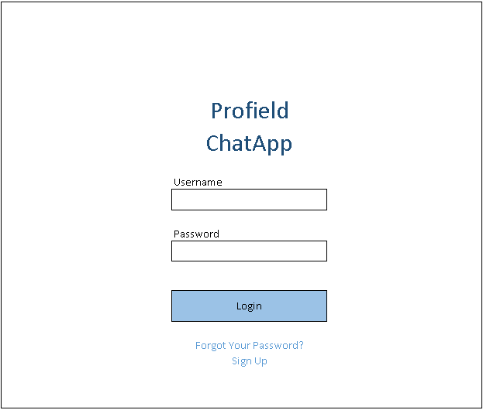

New User Sign-up Page
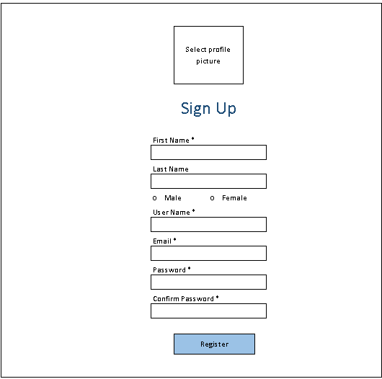

Chat Home Page
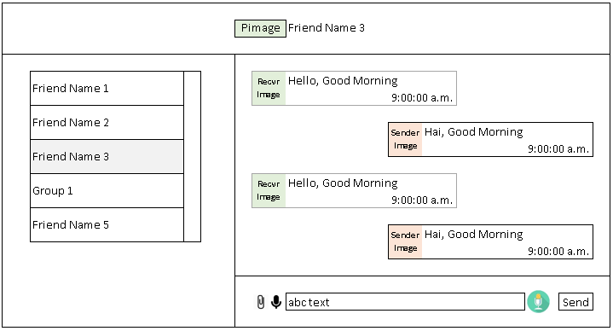

Request to add a Friend
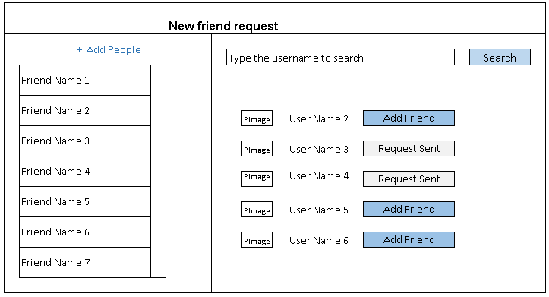

Manage Friend Request Page

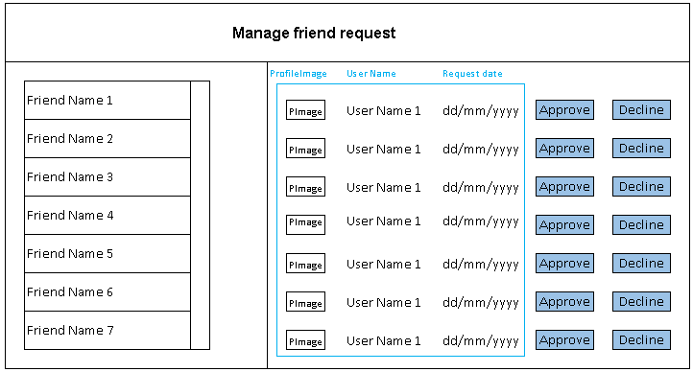

New Group Creation Page
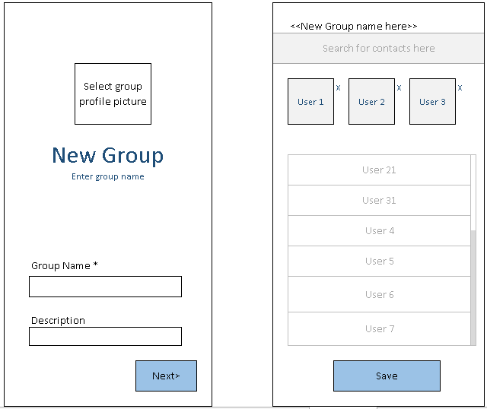

Edit Profile Page
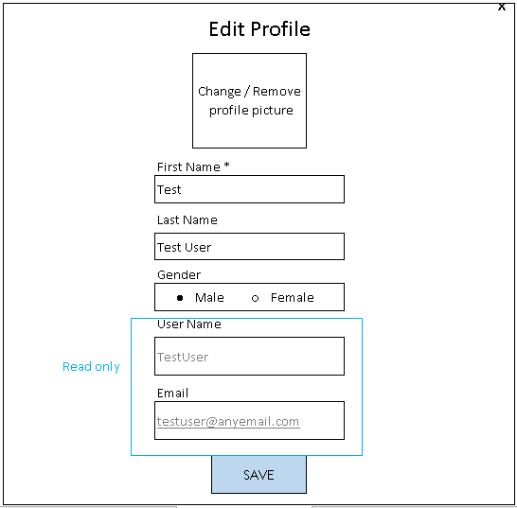

Hardware Interfaces
Not Applicable

Software Interfaces

Operating System : Linux CentOS 7.6 (7-6.1810.2.el7.centos.x86_64)
Development Platform
Web application : Eclipse Oxygen Java 8, Spring Boot 2.0.8
Admin module : Eclipse Oxygen Java 8, Angular JS v1.9
IOS app : XCode 10.3, Swift 4
Mongo DB versions : 3.4.19
Third Party Tools : Google API (Voice to text conversion)
Recorder.js (Voice recording)

Communication Interfaces
For each chat user, a websocket endpoint is created, with the unique id for each chat user.
All websocket communication is using the endpoint \socket
IOS client is accessing the chat functionality using the end point \api

Acceptance Criteria

Acceptance criteria are based on the submission of demo on each completion stage and final submission of the Integrated Tested Application.
- Voice chat message and Voice to text message should be working as per the industry standard
- All user requirements should work as per the industry standard

Appendices
Not Applicable

